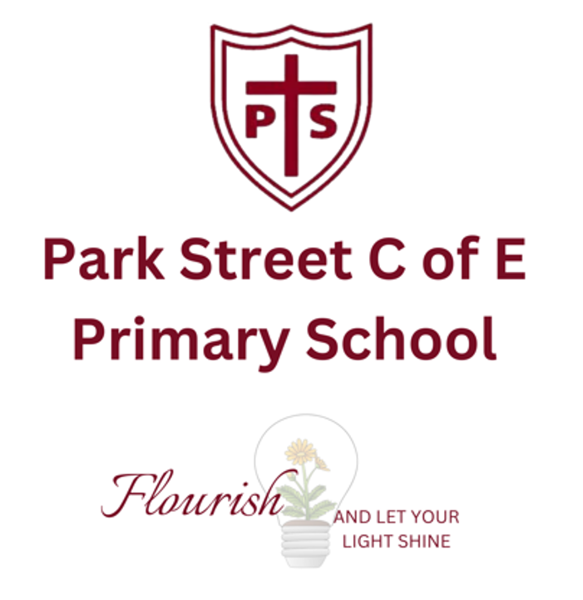

NURSERY APPLICATION FORM
for admissions in 2026

Park Street CofE Primary School and Nursery

If your child was born between 1st September 2022 and 31st August 2023, you can apply for a Nursery place to start in September 2026. However, we will also accept children in the term after their third birthday (subject to availability)

Parents apply directly to Park Street Primary School on the application form below. We have three intakes each year (September, January and April- with January and April subject to availability) and places are allocated according to the school’s admission criteria.

- We offer a term time only Nursery from Monday to Friday.
- All children are offered 15 hours of funded education for five mornings a week from 9.00am to 12.00pm.
- In addition, we offer 30 hours free childcare sessions daily from 12.00pm to 3.00pm. These sessions are free for eligible families. Families who are not eligible can also access the afternoon childcare sessions for a fee of £15.75 per day.

Timescale for September 2026 intake

Nursery applications open | 7th November 2025
Nursery application closing date | 20th February 2026
Nursery offer date | 6th March 2026
Deadline for parents to accept/decline places | 20th March 2026

Oversubscription criteria for Nursery
If there are more applicants than places, the same oversubscription criteria for admissions to Reception will be applied. Please see summary below:

1. Children looked after and children who were previously looked after, including those children who appear (to the admission authority) to have been in state care outside of England, and ceased to be in state care as a result of being adopted.
2. Children with a sibling who will be enrolled in the school at the time of admission.
3. Children who live in the ecclesiastical parish of Frogmore which includes Park Street, How Wood, Frogmore and Colney Street. Priority will be given to those who live nearest to the school.
4. Children who live in one of the surrounding parishes of St Stephens, St Peters, London Colney, Shenley, Radlett, Bricket Wood or Aldenham (A map showing the parish boundary is available at www.achurchnearyou.com) and whose parents regularly worship at Holy Trinity Church and whose Supplementary Information Form (SIF) has been signed by the Vicar.
5. Children who live in one of the surrounding parishes of St Stephens, St Peters, London Colney, Shenley, Radlett, Bricket Wood or Aldenham (A map showing the parish boundary is available at www.achurchnearyou.com) and whose parents regularly worship at any other Christian Church and whose Supplementary Information Form (SIF) has been signed by the Vicar.
6. All other children.

PARK STREET CofE PRIMARY SCHOOL AND NURSERY
APPLICATION FORM

CHILD’S DETAILS
First name:

Middle name:

Family name:

Date of Birth: |  |  | Gender: |  |  | M/F
Child’s permanent home address:
Please supply a recent (within the last 3 months) original utilities bill or equivalent
Special Educational Needs  Does your child have an Education, Health and Care Plan which names the school |  |  |  | Yes/No
Children in Public Care  Is your child looked after, or was previously looked after and is now adopted or with a child arrangement or special guardianship order |  |  |  | Yes/No
Children whose parents/guardians regularly worship at Holy Trinity Church/another Christian Church and are applying under criteria 4 or 5 |  |  |  | Signature of Parish Priest verifying attendance
Early years setting your child attends or has attended:

PARENT/CARER DETAILS
Title:
Forename:

Surname:

DOB:

National Insurance Number:
National Asylum Support Service (NASS) Number (if applicable):
Address (if different to child’s address):
Email address:

Telephone numbers:
Daytime
Mobile

OFFICE USE ONLY: |  | Date Received:
 |  | Distance:

I confirm that the information I have given on this form is complete and accurate. I understand that if any part of this completed application form is found to be false the offer of a place will be withdrawn.

Should my child be accepted as a pupil, I agree to abide by the School Aims and methods of working.

I understand that, if offered a place in the Nursery, I will have to apply separately for a place in Reception.

Signature of parent/carer: Date: `

Please return this form to the school office by Friday 20th February 2026
admin@parkstreet.herts.sch.uk

